Assigement no 9

1) Write a query that lists each order number
followed by the name of the customer who made the
order.
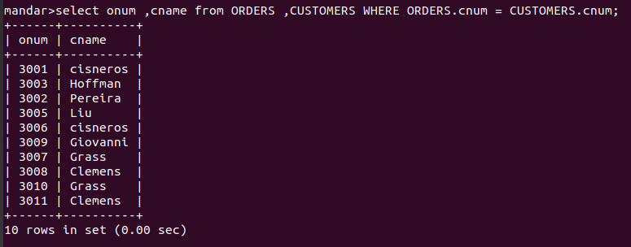

2) Write a query that gives the names of both the
salesperson and the customer for each order along
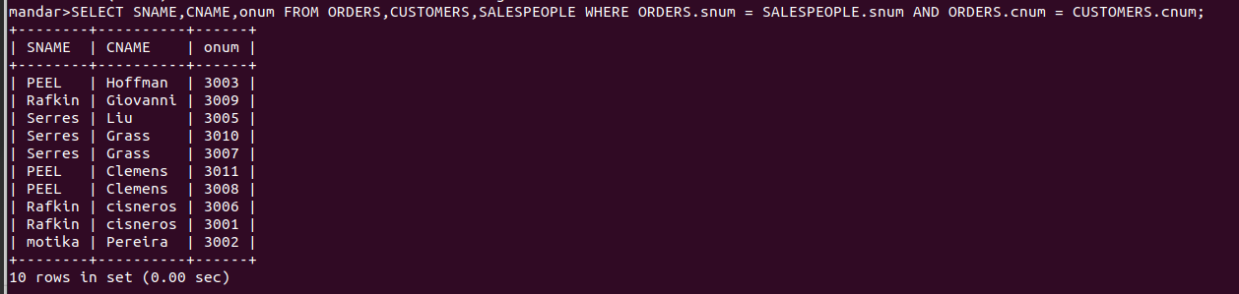
with the order number.

3) Write a query that produces all customers
serviced by salespeople with a commission above
12%. Output the customer’s name, the salesperson’s
name, and the salesperson’s rate of commission.

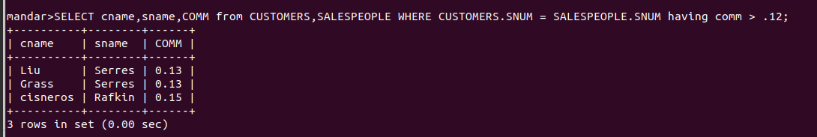

4) Write a query that calculates the amount of
the salesperson’s commission on each order by a
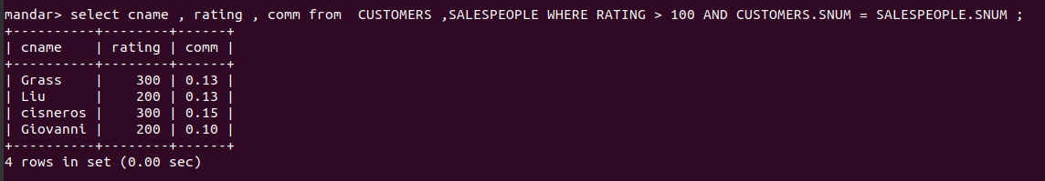
customer with a rating above 100 .

